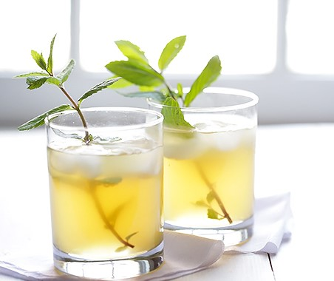
Ingredients
- 5 lemons juiced
- 1 bunch fresh peppermint
- 1 ½ cups sugar
- 1 ½ cup water
- 3 qts. Ginger ale
- Ice
Instructions
Add sugar and water to a sauce pan over medium-high heat. Warm up until sugar dissolves toss in the mint. Let the mint syrup cool. Squeeze the juice from the lemons through a strainer to remove any seeds and pulp into a pitcher. Add the mint syrup and ginger ale and mix. Add the ice. Serve ice cold.

